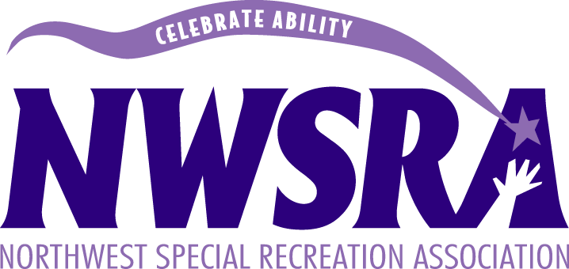

NINJA STRESS BALLS
Supplies:
- 2 balloons for each stress ball.
- Scissors
- Sandwich baggies
- Flour
- Black sharpie or pen
Directions:
Step 1: Cut the seal off the baggie if it has one. Fill a baggie with ¾ cup of flour.
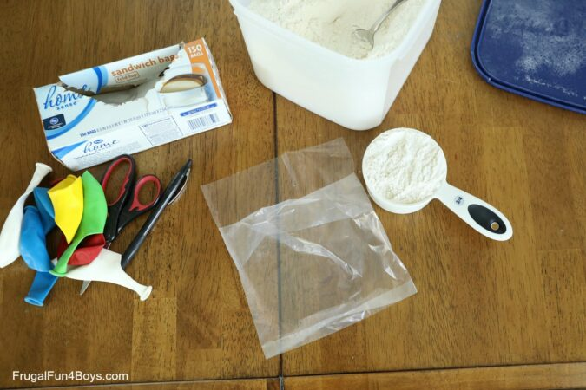

Step 2: Fold over the baggie and squeeze out all the air. Cut the blowing end of a balloon off. Whatever color you want to be the face so that you are left with a round balloon with a hole.

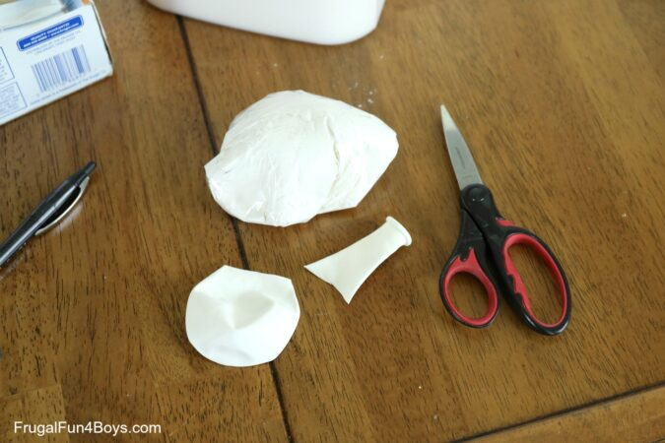

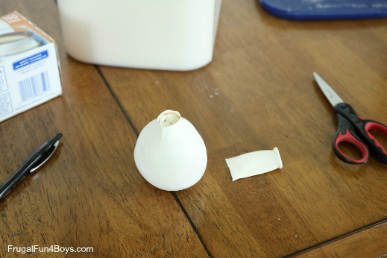
Step 3: Stuff the baggie filled with flour into the balloon.

Step 4: Cut off the blowing end of another balloon. Cut a small slit in the balloon for the ninjas face. Then stretch the balloon over the other balloon. The opening of the balloon with the baggie should go inside the other balloon so that the opening is covered and can’t come out. Then draw a face on the ninja with the sharpie.
