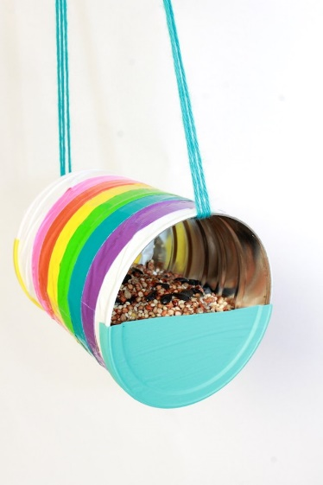
How to Make Recycle Can Bird Feeder
Supplies:
- Used coffee can with plastic Lid
- Can opener
- Craft paint
- Paintbrush
- Scissors
- Duct Tape
- Yarn
- Birdseed

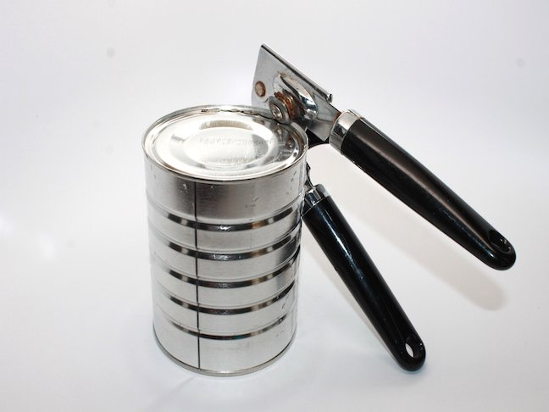
Instructions:
Step 1: Clean and open your coffee can with a can opener.

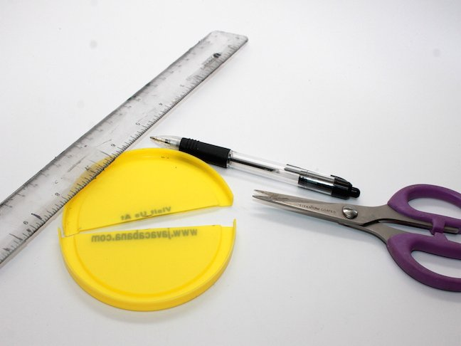
Step 2: Cut the coffee can’s plastic lid in half.

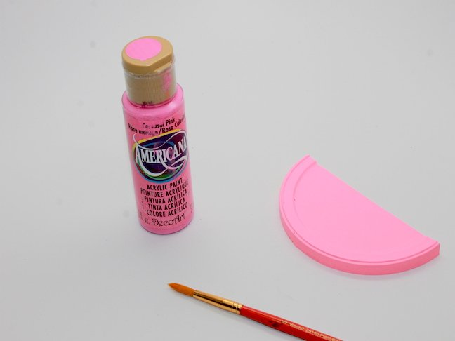
Step 3: Paint your coffee can lid halves. Let dry.

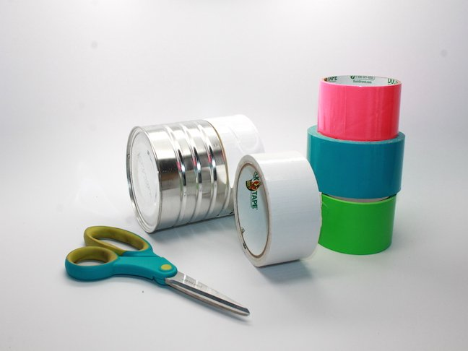
Step 4: Decorate your can with colorful duct tape. Tips: Layer the tape on top of each other to create different widths.

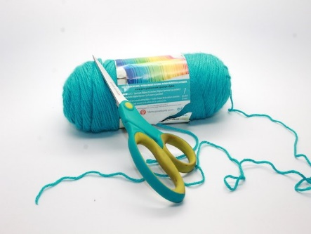
Step 5: Cut yarn or ribbon at your desired length. Thread it through your can. Place the half lid on either side of the can.

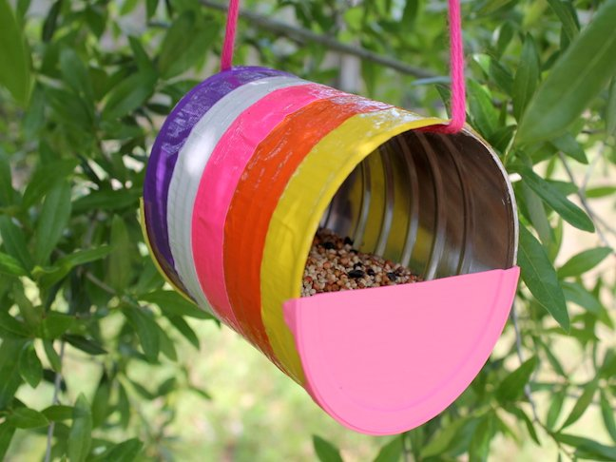
Step 6: Fill your can with birdseed and hang outside.
Project complete!

