Coffee Filter Peacock Craft

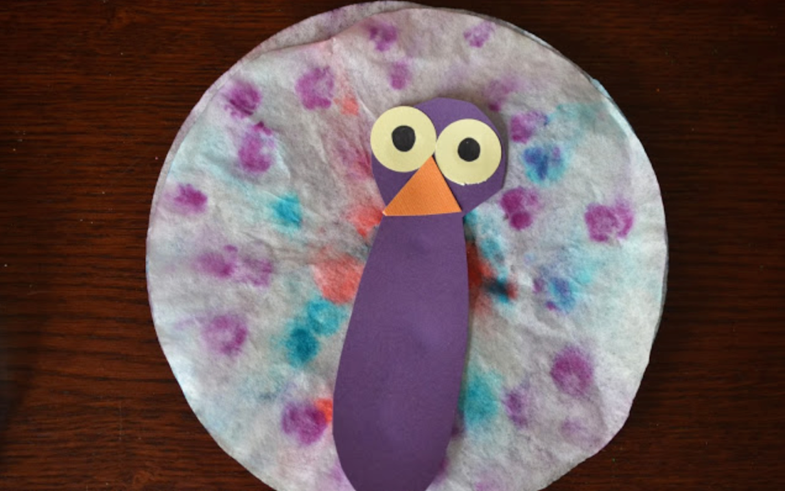

Material needed:

- Coffee filter
- Markers
- Spray bottle filled with water OR a small cup and water
- Construction paper
- Scissors
- Glue
- Paper towel

Instructions:

- Use markers to make dots, swirls, whatever design you like on the coffee filter
- Wet the coffee filter and watch the colors spread! Depending on you materials, follow a or b.
- Use the spray bottle filled with water to spray the coffee filter
- Fold the coffee filter in half, then in half again. Fill the cup with about a half inch of water, and stick the pointed end of the filter into the cup. Let it sit for a little while to absorb water all the way through!
- Place the coffee filter flat on a surface covered in paper towel to let it dry.
- While the coffee filter dries, use your scissors to cut out the shape for the peacock’s body, beak, and eyes!
- Once the coffee filter is dry, glue the peacock body onto the filter, and glue the beak and eyes onto the peacock!
- You’re finished! Place your creation somewhere to display its bright and beautiful colors! We recommend somewhere with lots of light, or even taping it to or hanging it on a window!

