Paper Plate Rainbow Craft

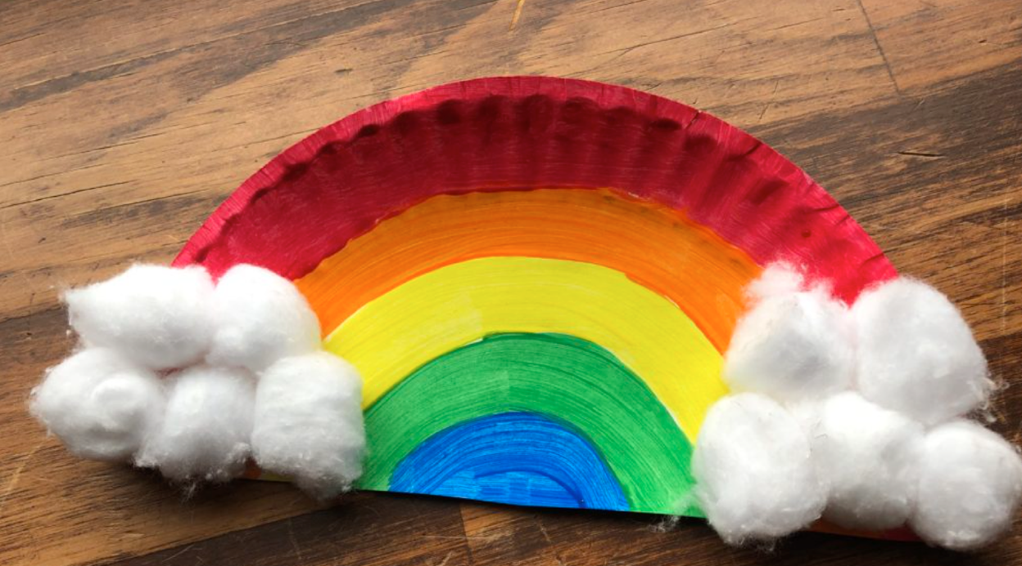

Materials:
- Paper Plate
- Scissors
- Markers OR Paints and brushes
- Glue
- Cotton Balls

Instructions:
- Use your scissors to cut the paper plate in half. Discard one half, or you can use both to make two rainbows!
- Use your paints or markers to draw the rainbow colors onto the paper plate half. Let dry!
- Use glue to glue the cotton balls to the sides to make big, fluffy clouds!
- You’re finished! Place your rainbow somewhere you would like to see it all the time and enjoy how nice your hard work turned out!

