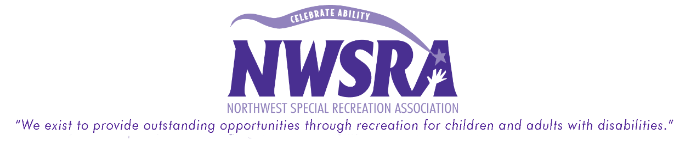
Set Up For Success- Key Points At-a-Glance
- Structure—Structure is essential to a smooth-running program. Understanding the parameters of a program eliminates the vast majority of behaviors from a group. It is important that the group is aware of the schedule, and that there is as little down-time as possible.

- Positive vs Negative—When giving a directive, it is important to use positive phrasing. Tell the participant what you want him to do, not what you don’t want him to do. The more specific your directives, the easier they are to follow.
    - “Sit down on the green line,” instead of “Stop running around”

- Allow for Processing Time—All children process information more slowly than adults. When giving a directive, allow time for the child to process what you have asked him. The more a directive is repeated the more confused the child gets, which decreases the likelihood of it being followed.

- Less is More—Using too many words can dilute the clarity of a directive. Use concise sentences that are very clear. Using visuals (pictures) greatly enhances comprehension with visual learners.

- Have a Device—Having a “attention-grabber” device will help you engage the group quickly and efficiently. The device needs to be calm, simple, quick, and easily visible. If you are trying to get the group’s attention by yelling, the lesson being taught is that yelling is acceptable at your program.

- Set Clear Expectations—Don’t assume that kids know the rules. Even rules common to all programs (e.g. keep your hands to yourself; walk don’t run; keep your clothes on) may not be at the forefront of a child’s mind. Take time to go over expectations with the group. It is most effective when the children tell you what rules they can think of. Once you have a list, post it somewhere the kids can see it. If there is an issue, you can use it to reference what he/she needs to do next time.
- Have Fun—You’re working with kids, not in a cubicle! Be energetic and enthusiastic— the children are more likely to go along with what you want them to if it seems like you’re having fun.

Behavior Management:
Things to keep in mind…

- What is the behavior communicating?
- Children (especially children with disabilities) often have difficulty communicating their needs effectively. They use behaviors to express their frustration that their specific needs are not being met.

- Are the expectations clear?
- Expectations need to be clear, simple, and reasonable. They need to be stated prior to the activity.
- When restating expectations, direct the participant to what you want them to do. E.g. “You need to walk,” vs. “No running.”

- Avoid a power struggle!
- Never get into a “Yes you will! No I won’t!” conversation. They are counterproductive and are allowing the participant to dictate the course of the conversation.
- Refer the participant back to the directive, and…

- Give choices!
- Phrase directive in choice format whenever possible; an element of control is often enough for participants who are engaging in inappropriate behavior.
  - E.g. “You can sit ‘here’ or ‘here’,” “You can leave now or in five minutes”
- When not potent enough, phrase the positive choice first, then the negative with the appropriate consequence.
  - “You can stand up and walk with your group, or choose to sit there and miss dodgeball.”
- Be reasonable!
- Nothing in this field is “black and white”. Make certain a participant is able to meet your expectations. Depending on a child’s ability level, he/she may not be able to be held to the same expectations as his/her peers.

