

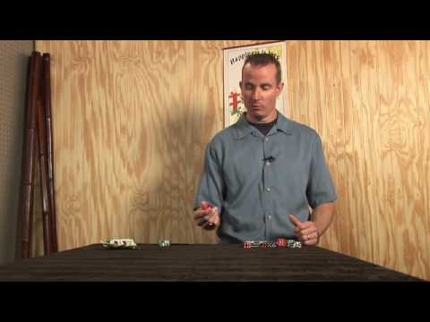
Dice Bowling

How to Play:
- Choose a player to go first
- The player going first will roll the dice, and add up their score
- If a player rolls two fives, it counts as a strike and two sixes counting as a gutter ball (losing their turn)
- If a player rolls a 5, they then only roll on die one the second turn and collect their score
- If a player does not roll a 5, that player counts their score, and that’s what they receive for the frame
- Players will only roll twice if they roll one 5
- Regular bowling 10th frame rules apply
- At the end of 10 frames, the player with the highest score wins
Supplies Needed:
- 2 Dice
- Scoresheet
- Pencil

