

**[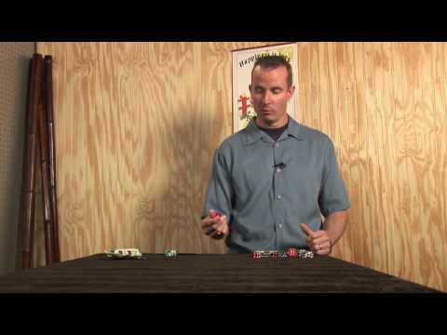](https://www.youtube.com/watch?v=sTVRA5o9Yqw)Dice Bowling**

**How to Play:**

1. Choose a player to go first
2. The player going first will roll the dice, and add up their score
3. If a player rolls two fives, it counts as a strike and two sixes counting as a gutter ball (losing their turn)
4. If a player rolls a 5, they then only roll on die one the second turn and collect their score
5. If a player does not roll a 5, that player counts their score, and that’s what they receive for the frame
6. Players will only roll twice if they roll one 5
7. Regular bowling 10th frame rules apply
8. At the end of 10 frames, the player with the highest score wins

**Supplies Needed:**

* 2 Dice
* Scoresheet
* Pencil



