How to Make Suncatcher with Glue
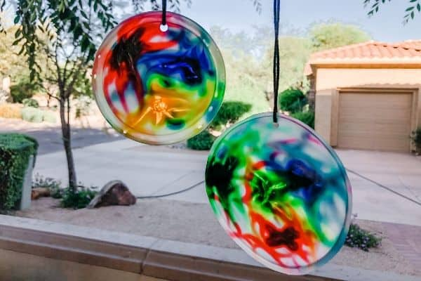
Supplies:
- Elmer’s white glue
- Food coloring
- Toothpick
- Plastic lid (the lid needs to be flexible enough so you can bend it to get the suncatcher out)
- Hole punch
- String

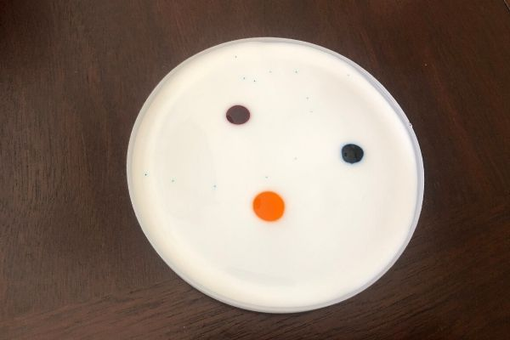
Instructions:
- Pour enough glue into the lid to cover the entire inner surface.
- Add drops of food coloring. **Tip: About 3 drops is more than enough.

- Swirl the colors around the glue with a toothpick.
- Let the glue dry until completely solid. Depending on how much glue you poured in the lid, it may take 2-3 days.
- When you see the edges starting to peel off the lid, you can peel off the glue.
- Punch a hole in the suncatcher with the hole punch.
- Insert the string into the hole.
- Hang the suncatcher in a sunny spot.

