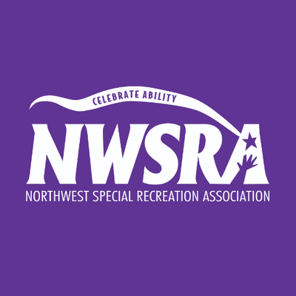

I SPY SENSORY BOTTLES
Supplies:
- Empty water bottle
- Water
- Clear glue
- Food coloring
- Beads, seas shells, buttons
- Super glue
Directions:
- Fill an empty water bottle 1/2 way with warm water.
- Fill the remaining space in the water bottle with clear glue.
- Add 2 drops of food coloring.
- Add glitter.
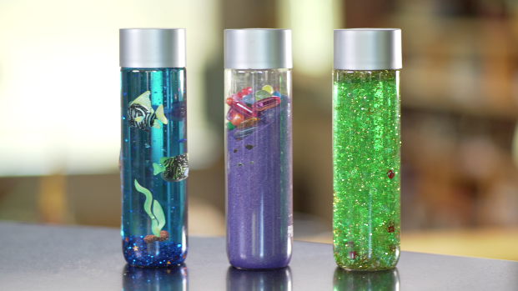
- Add seashells, buttons and beads.
- Mix it up!
- SUPER GLUE THE LID!

FIREWORKS IN A JAR
Supplies:
- Jar
- Water
- Food coloring
- Bowl
- Fork
- Oil
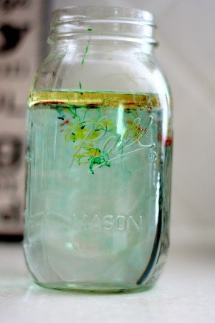
Directions:
- Fill your jar 3/4 of the way full with warm water.
- In a separate bowl, mix 3-4 tablespoons of oil and several drops of different colors of food coloring
- Use a fork to mix the oil and food coloring together.
- Gently pour the oil mixture into the jar.
- Watch what happens—the food coloring will slowly sink out of the oil and into the water. When this happens, it will expand and begin to mix with the other colors.

