Goo Sensory Bags
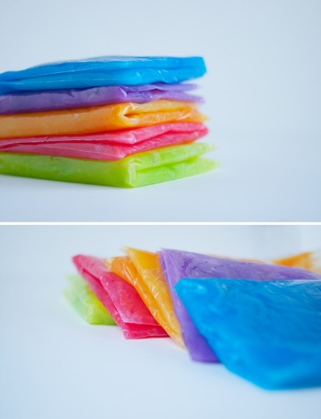
Supplies:
- 1 cup cornstarch
- 1/3 cup sugar
- 4 cups cold water
- food coloring
- sealable bags –gallon freezer size

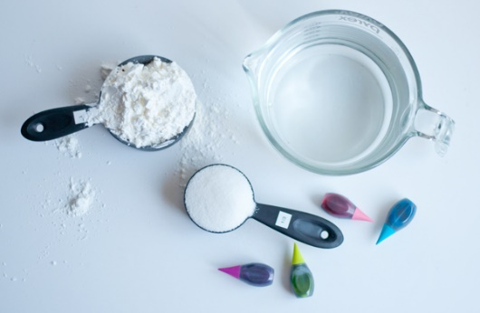
Directions:
- Whisk all the ingredients together in a pot over medium heat.
- Continue to cook it all together, whisking frequently. As the mix thickens and solidifies, make sure to keep whisking.
- You will know the goo is getting to the right consistency when it changes from a white liquid to a blueish, clearish goo. It will look like Vaseline.
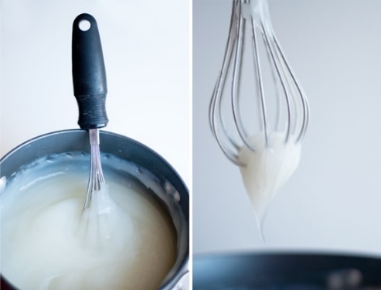
- Once it’s finished, pull it from the heat. At this point, you can add coloring. Wait until it has cooled to add it to the bags. I found it easiest to add the cooled goo to the bags and then drop in the color.
- Then with a bit of squishing, the color gets mixed in. For extra security, you could place tape over the zipped opening or double bag it.

