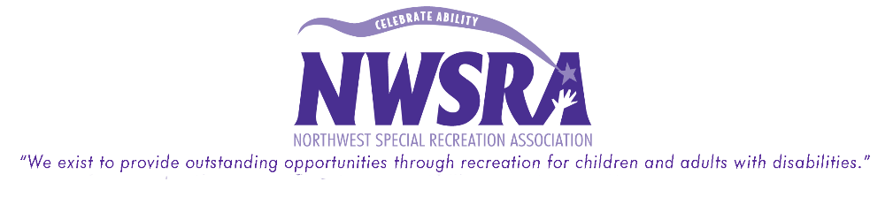

Initial Participant Intake
What to do after the ADA box is checked
Please ensure that you are not guaranteeing the Park District/NWSRA will be providing an additional staff at the program. The first step you should take is contact parents/participant. Inform them of the purpose for your call (“I am calling because I noticed that you had checked the Americans with Disabilities (ADA) box on the registration form when signing up for __________ program.”)
Then, proceed with the following questions:
1. “What are the participant’s goals for this program?”

2. “What part of the program will the individual need additional support?”

3. “Have the individual registered ever received support in a park district setting before?” (If yes, continue with these questions)
3a. “What type of support has the individual received?”

3b. “What type of program was the support received in?” (swimming, day camp, etc.)

If they respond that that have NOT received support, explain the park district’s relationship with NWSRA and the Inclusion Process.*Use the Inclusion Handbook if you need assistance with your explanation.
4. “Tell me about you/your child.”

5. State what the park district staff can do to provide support for them/their child. (support other than NWSRA aide support)

6. “Our participant to staff ratio for this program is ________. Do you believe you/your child can be successful within that ratio?”

7. “Keeping all of this information in mind, I will talk it over with my team and NWSRA to figure out the best way to support you/your child in our programs.”

After this conversation takes place, contact the NWSRA Inclusion Coordinator for your area with the information discussed.

