POKEMON BOOKMARKS
Supplies:
- Colored craft papers
- Pencil
- Scissors
- Craft glue
- Markers
- Printed Template (also in activity center)

Directions:
- To make the Pikachu craft bookmark, cut a 5.5 inch square piece of yellow paper.

- Fold the square paper into half diagonally, corner to corner.

- Now that you have a triangle shape, fold the bottom right corner of the triangle to the top corner. | 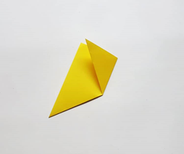
- Next, fold the bottom left corner of the triangle to the top corner. | 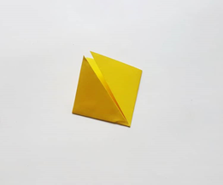
- Unfold both previous folds. | 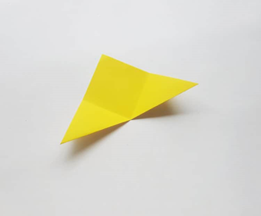
- The top side of the triangle has 2 layers of paper. Fold the top corner of the front paper layer to the bottom. | 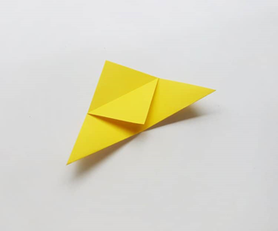
- Fold up the right bottom corner, along the already created fold line. Tuck the top half of the triangle into the bottom to create a pocket. | 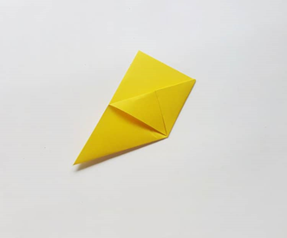
- Do the same thing to the left side- fold up the bottom corner on the previous fold line, then tuck it down into the pocket.

- The basic paper corner bookmark is now ready. Simply turn the bookmark over to the other side to create the Pokémon bookmark.

- Cut a curved border along the open side of the bookmark. Also cut out the ear and the eye for Pikachu using the template. Use the templates to make the face features on yellow paper.

- Use a marker to add details to Pikachu’s face following the pattern. | 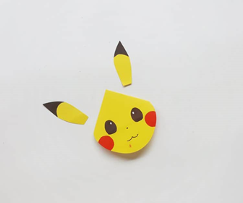
- Glue the ears to the top of Pikachu’s head. | 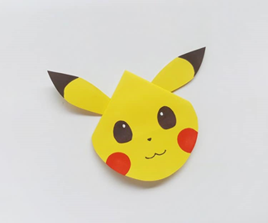
- Now create the Bulbasaur bookmark and Charmander bookmark using the same steps and the template.

