DIY WATERCOLOR- EFFECT MUGS
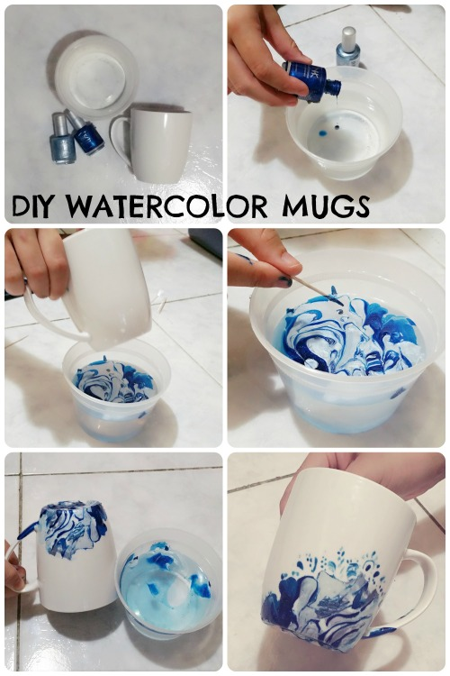
What you’ll need:
- Ceramic mug (any shape or size)
- Nail Polish - preferably 2+ colors
- Disposable container
- Toothpicks

HOW TO MAKE IT
- Fill the container with warm water - make sure it’s not filled all the way, so the water won’t spill over when you dip the cup in!
- Pour some of your nail polish colors in the container one at a time. (I used two, but I can see it working with more colors!)
  - Note: for me, the nail polish got on the container, and I had to toss it out. Make sure it’s a disposable container!
- Use the toothpick to mix the colors into an interesting pattern one stroke at a time! (the nail polish is thick and won’t mix together if you don’t stir too much)
- Dip your cup into the mixture - I stayed away from dipping the top where people drink
- Optional - Use the toothpick to design with the clumps of nail polish on the mug or left in the container for extra customization!
- Let dry for 2-3 hours.
Hand wash these only! Otherwise, put on some dishwash safe Mode Podge as a sealant.
The mug will smell like nail polish afterwards, but with a good (careful) wash, the smell should go away.

