NAIL POLISH MARBLE MUGS
Supplies:
- Toothpicks
- Large/deep bowl
- Water
- Multiple nail polish colors
- White ceramic mug

Directions:
- Fill a bowl with warm water.

- Drop as many colors of nail polish in the water until you get the desired marble effect.

- Dip the mug in the water straight down and use the toothpicks to pick up excess nail polish that hasn’t adhered to the mug

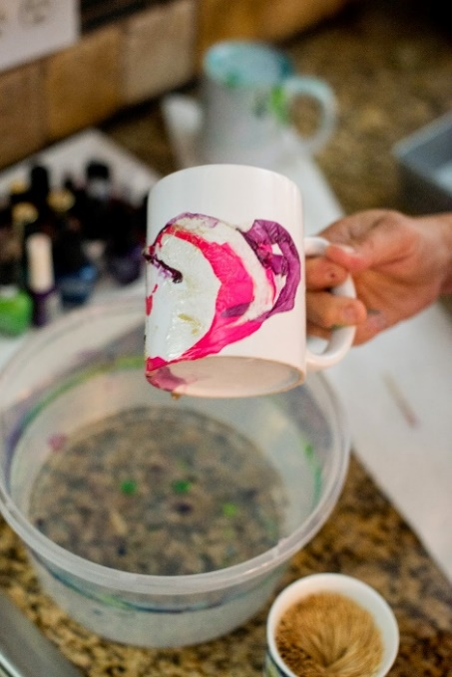
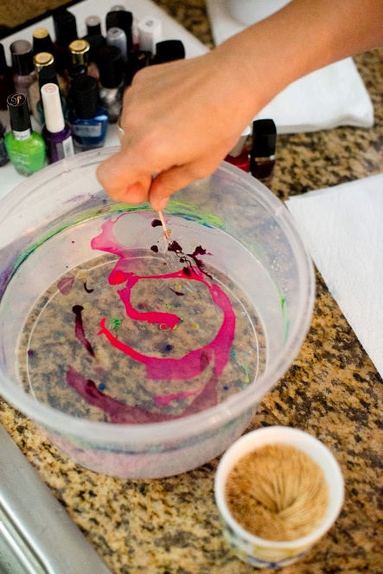
- Pull the mug out and let dry.

